Instruction Fine-tuning

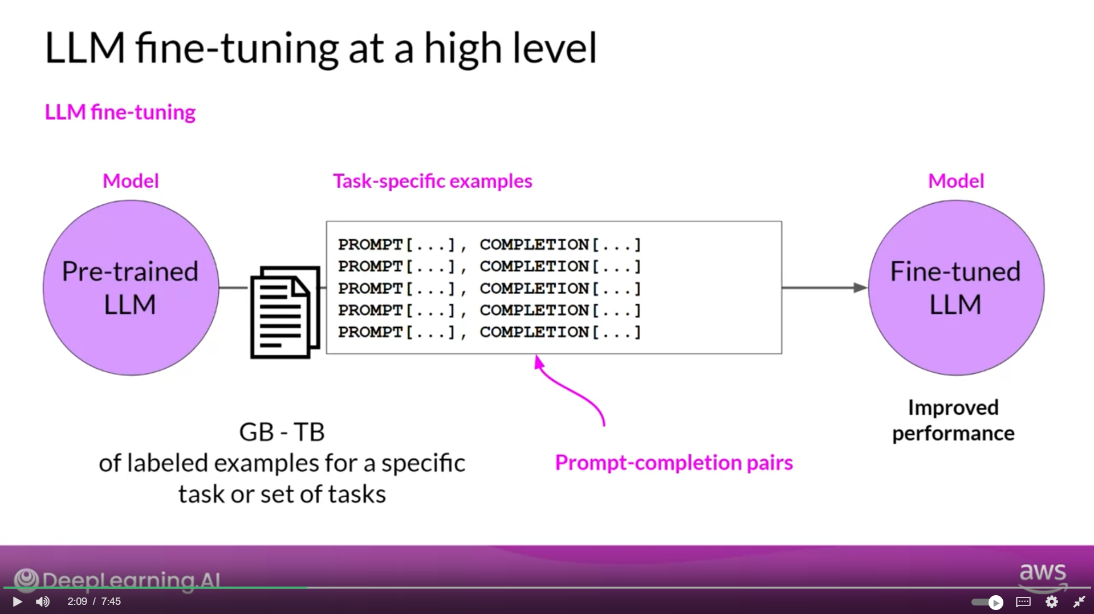

The labelled examples are prompt completion pairs, the fine-tuning process extends the training of the model to improve its ability to generate good completions for a specific task.

Fine tuning on a Single task

* Often just 500-1,000 examples can result in good performance in contrast to the billions of pieces of texts that the model saw during pre-training.
* However, there is a potential downside to fine-tuning on a single task. The process may lead to a phenomenon called catastrophic forgetting. Catastrophic forgetting happens because the full fine-tuning process modifies the weights of the original LLM. While this leads to great performance on the single fine-tuning task, it can degrade performance on other tasks.

Multi task Instruction Fine-tuning

* Multitask fine-tuning is an extension of single task fine-tuning, where the training dataset is comprised of example inputs and outputs for multiple tasks.
* One drawback to multitask fine-tuning is that it requires a lot of data. You may need as many as 50-100,000 examples in your training set.
* The resulting models are often very capable and suitable for use in situations where good performance at many tasks is desirable.